**MINOR PROJECT-1**



**END-SEM REPORT ON**

Fresh Fruit or Rotten Fruit Classification using Deep Learning

**Submitted by:**

Rohit Kumar 500082652 Ananya Dutta 500083514

**Under the guidance of -**

Dr. Hitesh Kumar Sharma

Sr. Associate Professor

Department of Cybernetics

Cybernetics Cluster

**School of Computer Science**

**UNIVERSITY OF PETROLEUM AND ENERGY STUDIES**

Dehradun – 248007

Aug-Nov, 2022

***Index***

***Contents Page Number***

Chapter 1: Abstract 3

Chapter 2: Introduction 4

Chapter 3: Problem Statement 5

Chapter 4: Literature 6

Chapter 5: Objectives 7

Chapter 6: Methodology 8

Chapter 7: Results Achieved 9-10

Chapter 8: System Requirement 11

Chapter 9: PERT Chart 12

Chapter 10: Conclusion 13

Chapter 11: Future Scope 14

Chapter 12: References 15

***Chapter 1: Abstract***

Detecting the rotten fruits have become significant in the agricultural industry. Usually, the classification of fresh and rotten fruits carried by humans is not efficient. If we do not detect the defected fruits, it may contaminate the fresh ones. The proposed model can perceive fresh and rotten fruits using inputs in the form of photograph data and help avoid the spread of rottenness. Precisely, we have used three types of fruits, such as apple, banana, and oranges. The project aims to increase the probability of supplying quality fruits, reduce human efforts, cost, and time for production by identifying the defects in the fruits. A Convolutional Neural Network (CNN) model is trained and used for extracting the features from input fruit images, and further classifying them. The performance of the model is evaluated on a Kaggle dataset. The results showed that the proposed CNN model can classify the fresh and rotten fruits with an efficiency greater than 95%.

***Chapter 2: Introduction***

Currently, AI is the buzzing term for the decade with its major contribution coming from Deep Learning. Thus, it becomes crucial to understand the basics of deep learning as they are changing the world we live in for the greater good. Speaking of Deep Learning, it is a sub-field of machine learning that deals with algorithms truly inspired by the structure and functions of a human brain. In simpler words, it mirrors the functioning of our brains.

India is one of the paramount fruit producers in the world. In the Indian agricultural sector, it is a huge problem to identify defective fruits and classify fruits as fresh or rotten. Since, it is quite difficult for industrial people to classify fruit quality using conventional methods, fruit classification needs new tools and techniques based on image processing. In order to identify the quality of fruits being supplied, we use a type of artificial neural network called Convolutional Neural Network (CNN). It is a part of Deep Learning which is widely used for image recognition & classification. In simpler words, Deep Learning makes use of CNN to identify objects present in an image.

In this project we are using deep learning to classify different varieties of apples, bananas and oranges into fresh and rotten categories. We will make use of the dataset which we have taken from Kaggle and with this we will train our model using deep learning so as to classify the fruits. We will make use of the dataset taking input in the form of images and then use the trained model to analyse the image and classify the given fruit as fresh or rotten. This model will basically work on deep learning. It will work in these steps. Firstly, we will train the model using a specific dataset. After our model is trained, we will test it by using different photos of

different varieties of fruits (apples, banana and orange). Our model will be trained for identifying the fresh and the rotten fruits among different varieties of apples, bananas and oranges.

So, with the help of images our model will work accordingly So that it can classify

the defined types of fruit. But this model cannot be 100% accurate as these are very small

examples.

***Chapter 3: Problem Statement***

In the recent years, classification of fresh and rotten fruits has become one of the significant issues faced by the agricultural sector and an emerging area of study which finds its application in various fields including artificial intelligence and deep learning. However, efficient systems for fresh fruit and rotten fruit classification are not readily available. Nonetheless, more and more research is being conducted in this emerging field to apply it in real world scenarios. Keeping the advantages in mind it is expected that demand for such models will grow in the near future. Hence, sooner or later efficient systems for fresh and rotten fruit classification will become a necessity.

***Chapter 4: Literature***

Agricultural sector has been advancing day by day. And this is because of the extensive research being conducted for the same. New technologies have been coming in use since the last few decades. Similar fruit classification studies were made in the past.

[1] Zhang and Wu in their research used SVM model for classifying the fruits into fresh and rotten categories. The difference here is: We are using CNN model rather than SVM. The benefit we are going to get from this is: CNN model can be trained and tested using large datasets. Whereas, SVM can handle only small datasets.

Moreover, CNN model is able to detects features much more precisely as compared to SVM model.

[2] Singh and Singh’s research was conducted explicitly for classification of fresh and rotten apples. But, we will be classifying a total of 3 fruits – apples, bananas, and oranges. So, there is going to be a single trained machine for classification of all 3 fruits.

***Chapter 5: Objectives***

**Objective achieved:**

* We have successfully implemented a CNN model that is responsible for classifying fruits into fresh and rotten categories using image as the input.
* The model is capable of identifying any image which belongs to any of the 6 classes for which the model is trained.
* We have completed loading and pre-processing of the data.
* Model is compiled and trained.
* Model is tested and improvised.
* The model attained an accuracy of 99.96%

***Chapter 6: Methodology***

**The methodology that we will follow for this project is a waterfall model.**

1. A deep study of the various colours and features of a fruit has a direct relation to its freshness and quality.
2. Analysis and classification of the fruits to determine the fresh fruits from rotten ones.
3. Selection of dataset including numerous images of different kinds of apples, oranges and bananas.
4. Selection of features for each fruit.
5. Data manipulation, reorganising and pre-processing of data to produce better results.
6. Selection and implementation of algorithms:

* To implement this fruit classification model, python language will be used with machine learning algorithms. Necessary libraries shall be imported. The data set containing fruit images must be there.
* Data is pre-processed as well as synchronisation of data from the repository with the algorithm is carried out.
* The working model of the project is formed and evaluated.

1. Training of the model and labelling of clusters.
2. Testing and improvisation of the model.

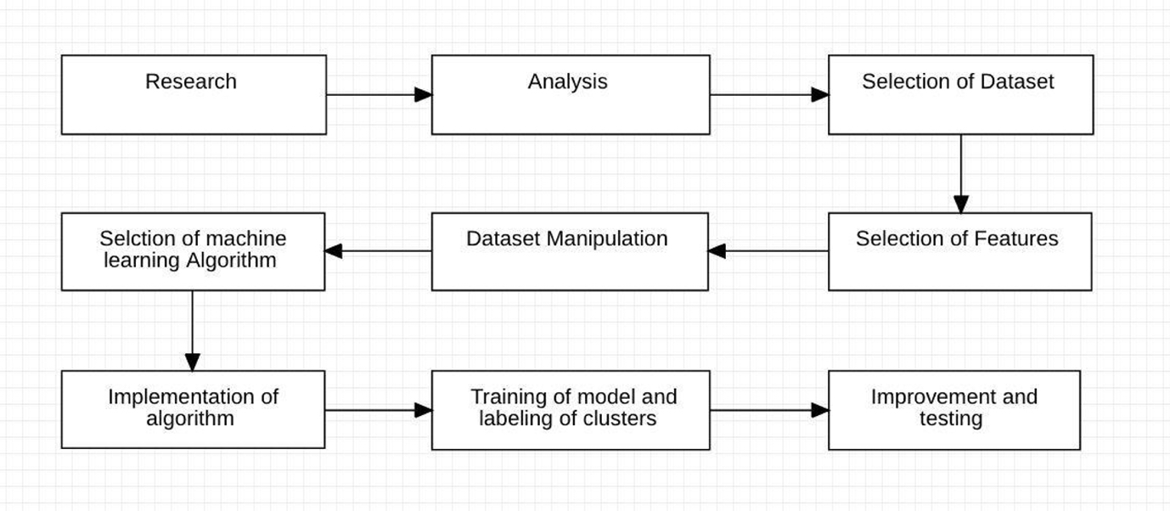

***Chapter 7: Results Achieved***

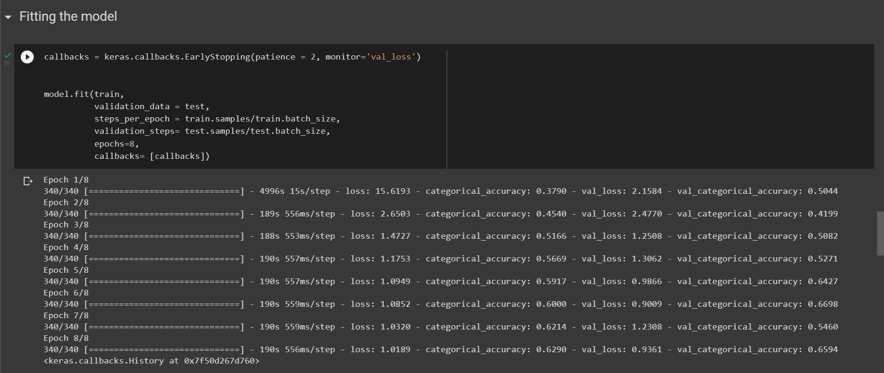

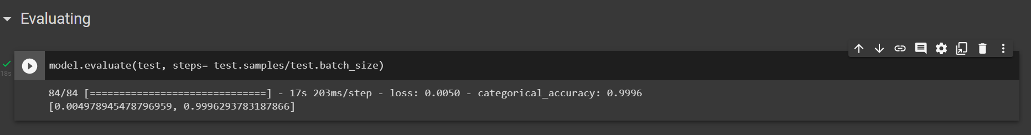

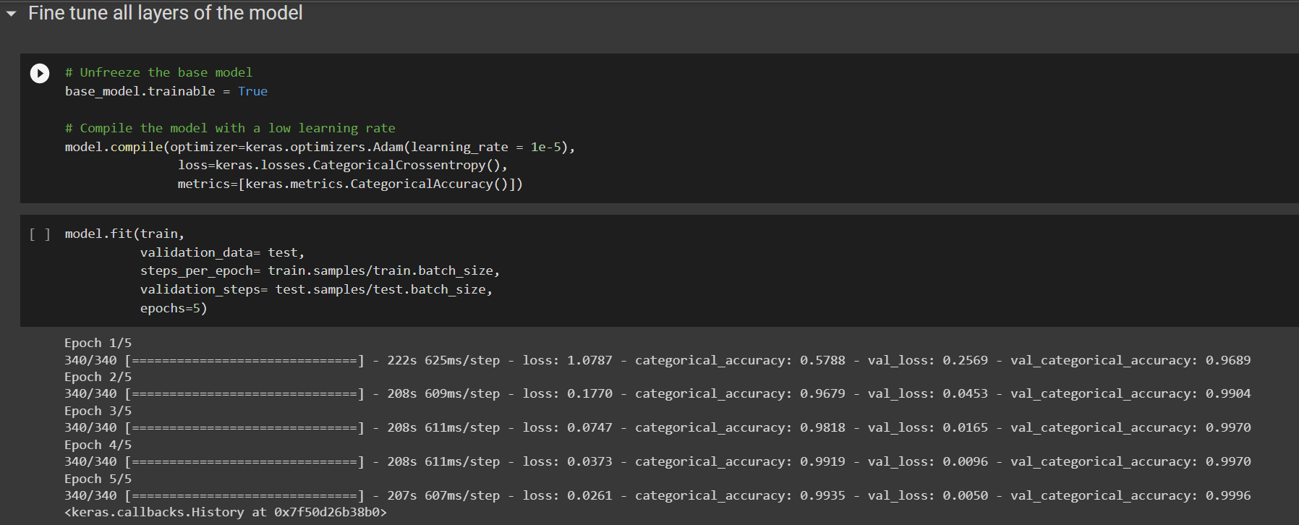

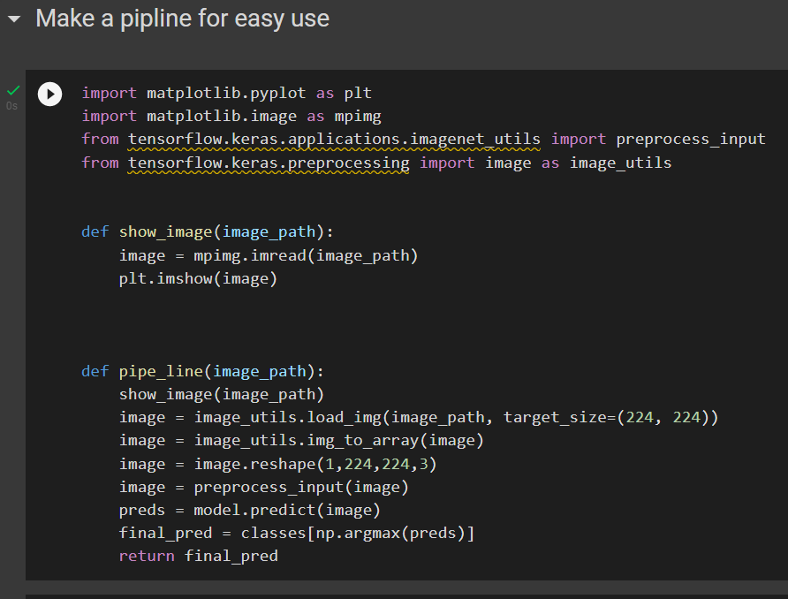

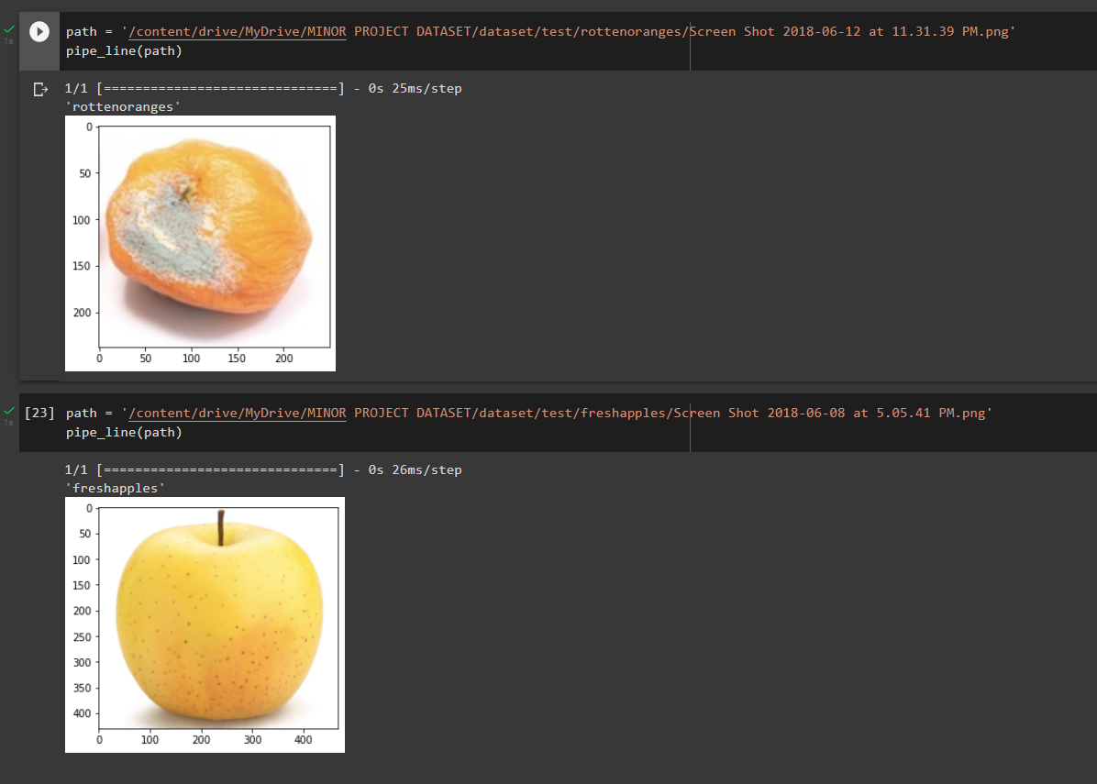

***Chapter 8: System Requirements***

1. **Software Requirements**

Operating System : Windows 11/10/8/7 (32-bit or 64-bit)

Software : Google Colab

1. **Hardware Requirements**

Processor : Dual Core 2.7 GHz or better

RAM : 4 GB or higher

Disk Space : 100 GB

***Chapter 9: PERT Chart***

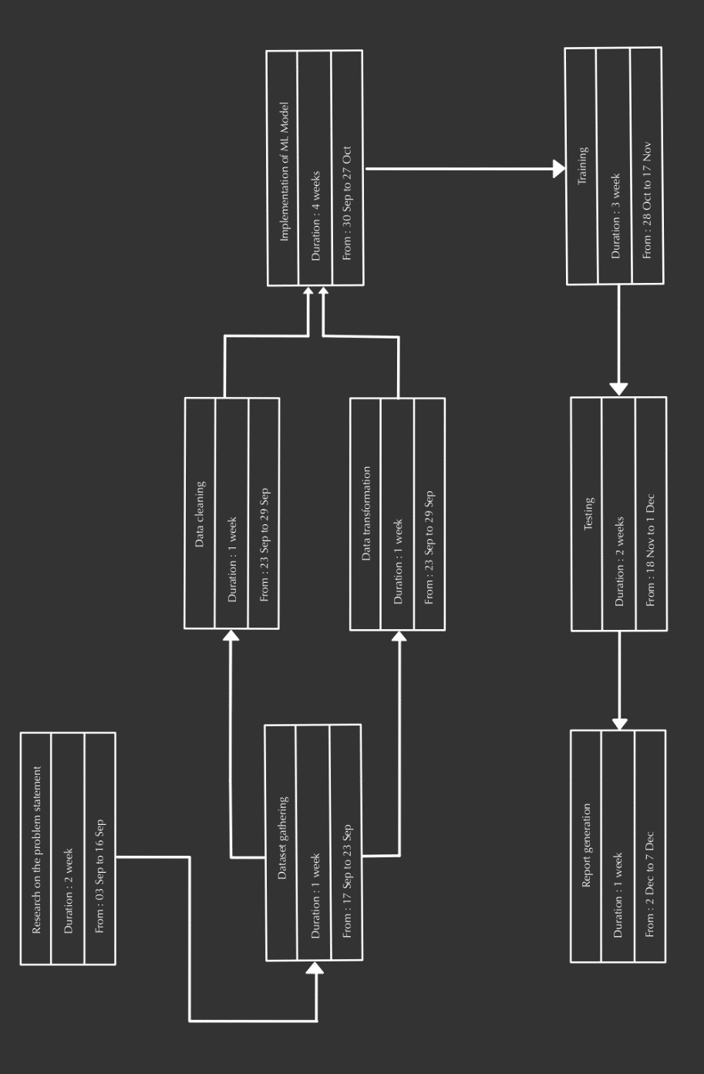

***Chapter 10: Conclusion***

The classification of fresh and rotten fruits is very important in agricultural fields. In our work, we introduced a model based on CNN and concentrated on building transfer learning models for the task of classification of fresh and rotten fruits. Transfer learning model InceptionV3 are used in this problem and the accuracies are compared against the proposed CNN model. The effects of different hyper-parameters i.e., batch-size, number of epochs, optimizer, and learning rate are interrogated in this work. The results proved that the CNN model proposed can classify fresh and rotten fruits firmly and produced better accuracy than transfer learning models. Thus, the proposed CNN model can automate the process of human brain in classifying the fresh and rotten fruits with the help of the proposed convolutional neural network model and thus reduces the human errors while classifying fresh and rotten fruits. The accuracy of 99.96% is attained for the proposed CNN model.

***Chapter 11: Future Scope***

The future extent for this work includes increasing varieties of fruits will be taken for classification, so that every fruit farmer will use the system. The work proposed is more useful for fruit yielding farmers for the classification of fresh and rotten fruits in yield so that they can get better cost price at markets.

***Chapter 12: References***

<https://www.kaggle.com/datasets/sriramr/fruits-fresh-and-rotten-for-classification>

<https://www.ibm.com/cloud/learn/deep-learning>

<https://www.ibm.com/cloud/learn/convolutional-neural-networks>

<https://ieeexplore.ieee.org/document/8946385>

[1] Y. Zhang and L. Wu, "Classification of fruits using computer vision and a multi-class support vector machine", Sensors, vol. 12, no. 9, pp. 12489-12505, 2012.

[2] S. Singh and N. P. Singh, "Machine learning-based classification of good and rotten apple", Recent Trends Commun. Comput. Electr., pp. 377-386, 2019.

**Approved by**

**Dr. Hitesh Kumar Sharma Dr. Hitesh Kumar Sharma**

Program Lead Program Lead

(Cybernetics Cluster) (Cybernetics Cluster)

Project Mentor Head of Department